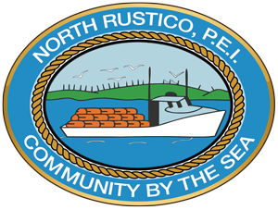

North Rustico Newsletter
July 2025
106 RIVERSIDE DRIVE, NORTH RUSTICO, PE C0A 1X0 (902) 963-3211 NORTHRUSTICO.COM
OFFICE HOURS: MON-THURS 8AM-4PM FRI 8AM-3PM
For information from the Town Office: Info@northrustico.com
For payments to the Sewer & Water Utility: SWPayment@northrustico.com
For payments to the Town: TownPayment@northrustico.com
Sewer and Water payments are payable by Cash, Cheque or E-transfer
Reminder, we do not accept Credit Cards for Payments




The Town Office will be closed Wednesday July 2nd,2025.

We would like to wish everyone a Happy Canda Day, a day filled with happiness, love and Canadian Pride .We have a great line-up for the day in the Town of North Rustico, hope to see you all taking part in the festivities.
A Big Thank You to everyone who makes this special day such a success .
Congratulations North Rustico Fire Department & The Town of North Rustico on the 70th Anniversary of Incorporation.
Mayor Heather Mckenna

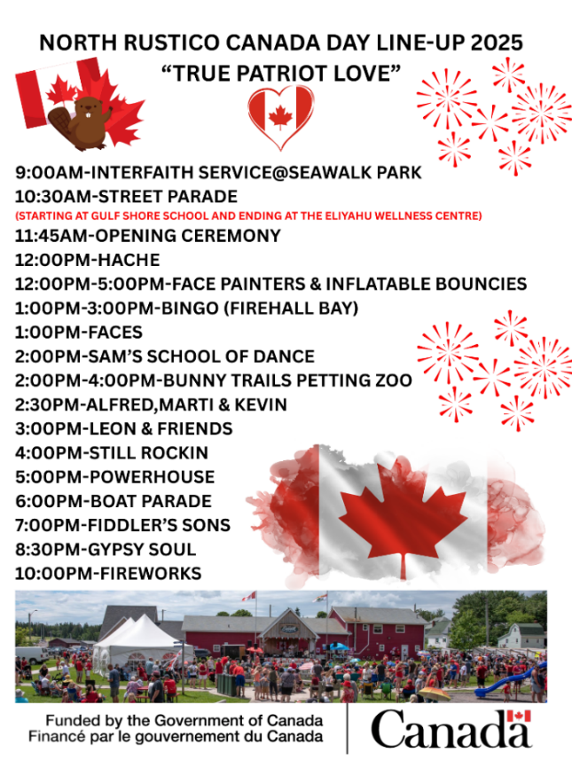
A big Thank You to the Provincial Credit Union for Sponsoring Music in the Park!
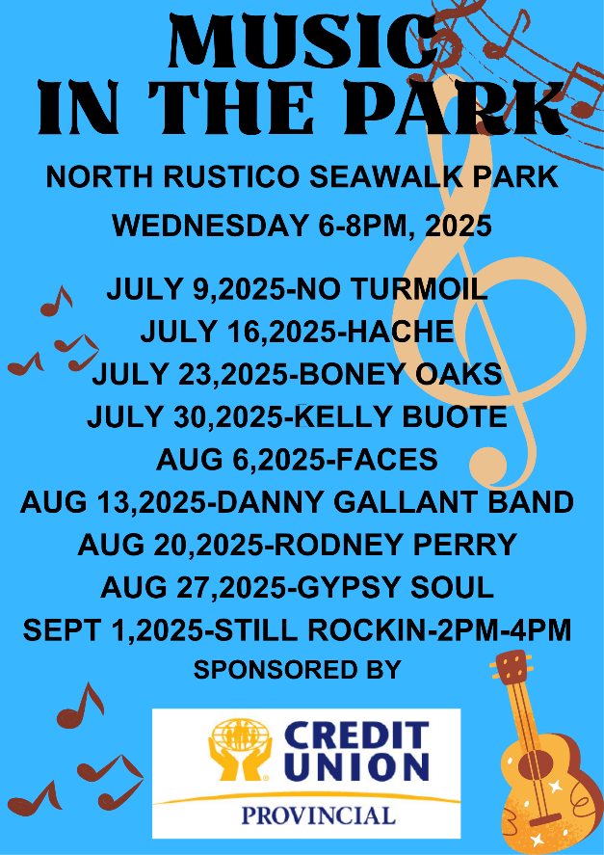

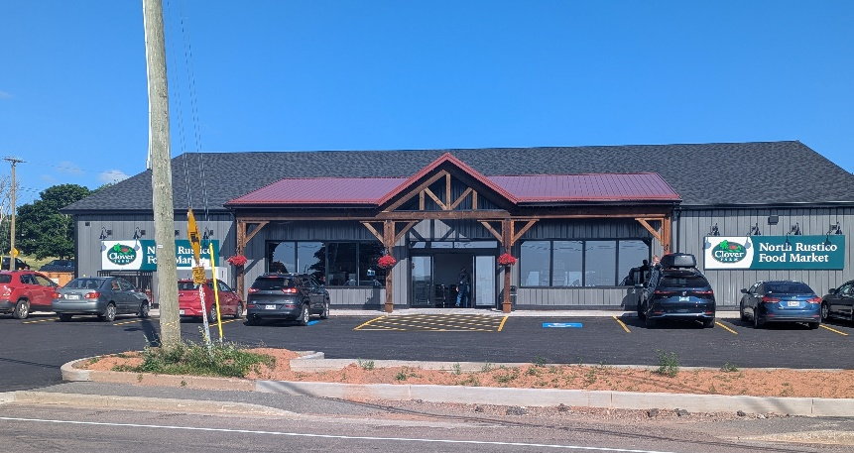

Neighbourhood Watch Program
If you or someone you know would like to
join or find more information about this program you can email the contact below

lauramoon_3@hotmail.com

North Rustico Food Market
Congratulations on the opening of the new store!!


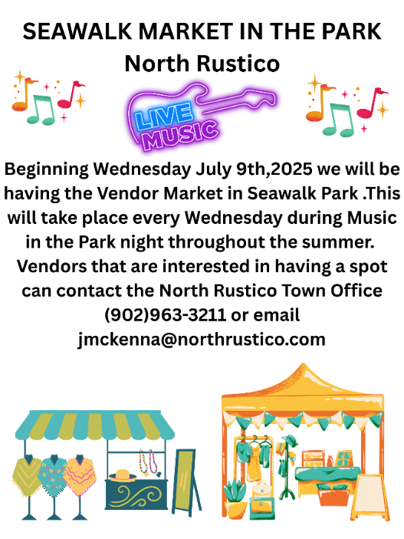

WATERMARK PRESENTS

Council Decisions May 5th
- Council approved the CIP Water and Sewer Capacity Analysis and Booster Pump in the amount of $346,000 and further approve the Mayor and CAO to sign agreements to fulfill this resolution.
- Council approved Central Coastal Tourism Partnership to apply for a special liquor permit for the Seawalk Block Party on Sunday June 1, 2025, from 2:00pm-7:00pm.
- Council, CAO to purchase a new Town maintenance truck at $41,700 +HST and to further approve the CAO and Mayor to sign agreements to fulfill this resolution.
- Council appointed Councillor Lana Penman to the North Rustico Lighthouse and Finance & Infrastructure Committees.
- Council approved the Town to provide a donation to the Watermark Theatre in the amount of $1000.


The Northshore and Cavendish summer transit service on Prince Edward Island has resumed and will run daily from June 16th to September 1st. This service connects Charlottetown and Summerside to North Rustico, Cavendish, and other north shore communities. One-way trips cost $2, and monthly passes are $20 for adults and $10 for seniors. You can book your trip on the Transit PEI Website. Route: Charlottetown, Summerside, Kensington, Stanley Bridge, Cavendish, North Rustico, Oyster Bed Bridge, and Winsloe.


This letter to the editor was published in the Guardian
Beautiful and Blessed Ground
I am a resident of North Rustico on Prince Edward Island, and I would like to talk about our beautiful cenotaph. About 10 years ago they moved the cenotaph from one location to another with a hill overlooking our little town main street. That was quite a feat by itself. The end result is a beautiful sight due to the hard work of the town and its maintenance gentlemen that takes pride in his work. As a veteran, every time I have a chance, I stop and walk up to monuments and think of all the sacrifices that veterans endured in all the past wars and their families staying behind and wondering all the time about their well-being. This morning, I was talking to the gentlemen as he was planting flowers around the monuments. I did not know exactly how to express to him our gratitude on behalf of all of us. If you ever have a chance, please stop by and take in the cenotaph. You will see how well maintained it is and make our town proud. Again, I would like to thank the town hall, the maintenance person and anybody who contributes to this beautiful and blessed ground as I am very appreciative of all the hard work it took to achieve. Peace to you all.
Simon Lemay, North Rustico, P.E.I.
The Town of North Rustico will be flying the Pride Flag in Seawalk Park from July 21st-July 28th.
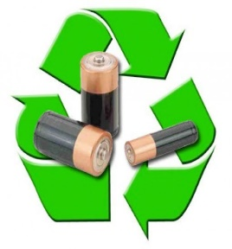
You can drop off your used batteries at the North Rustico Town Office or the Eliyahu Wellness Centre . We are officially a drop off site with Recycle your Batteries Canada powered by Call2Recycle.

